RSS Ticker User Guide

1-Installation

2-Usage

3-Potential Problems

Installation

To install the RSS ticker program, simply execute the install program. The program will then take you through a simple setup process and ask where you want the files to be installed. When the installation has finished, the program will appear in your start menu, and a shortcut placed on your desktop.

Usage

When the ticker is opened for the first time, you will see it dock to the bottom of your primary monitor, flush with the taskbar.



This window fills the width of your display, and will not be displaying anything at the moment.

To add a news feed to the ticker, click the “Settings” button, which opens the following dialog box.

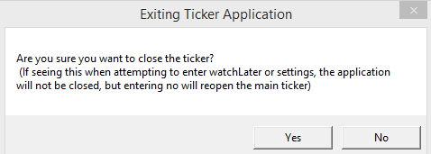

Pressing no at this stage will reopen the main ticker, but since we want to add a news feed, clicking yes will open the settings window, as below (On next page):

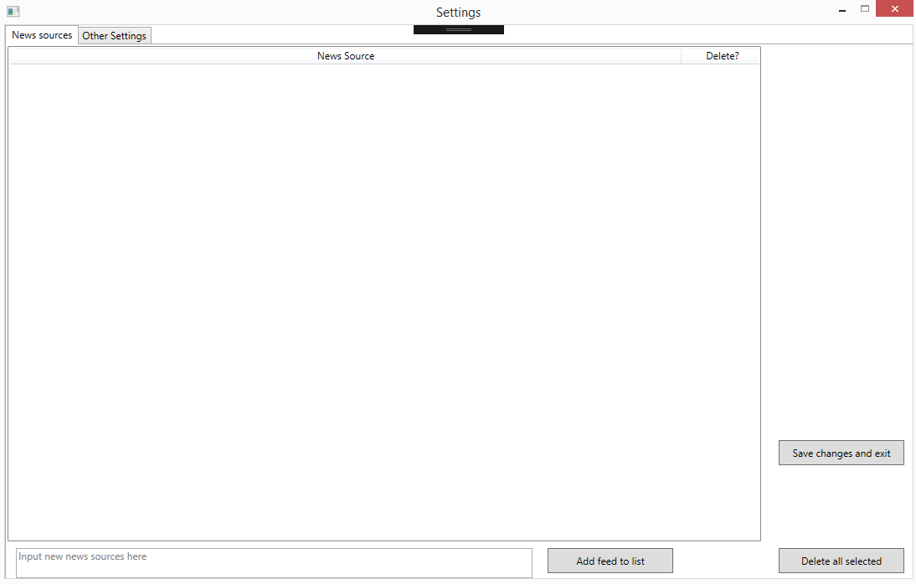Usage

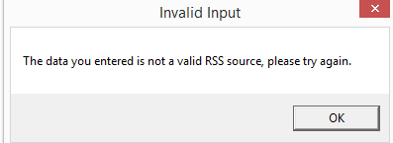Using the text box at the bottom, rss feeds can be typed in and then added to the list with the button “Add feed to list”. Typing in an invalid rss feed will produce the following message:

Taking the bbc UK rss feed as the example here (<http://feeds.bbci.co.uk/news/uk/rss.xml>), when adding it to the list, it will be displayed as follows(On next page):

Usage

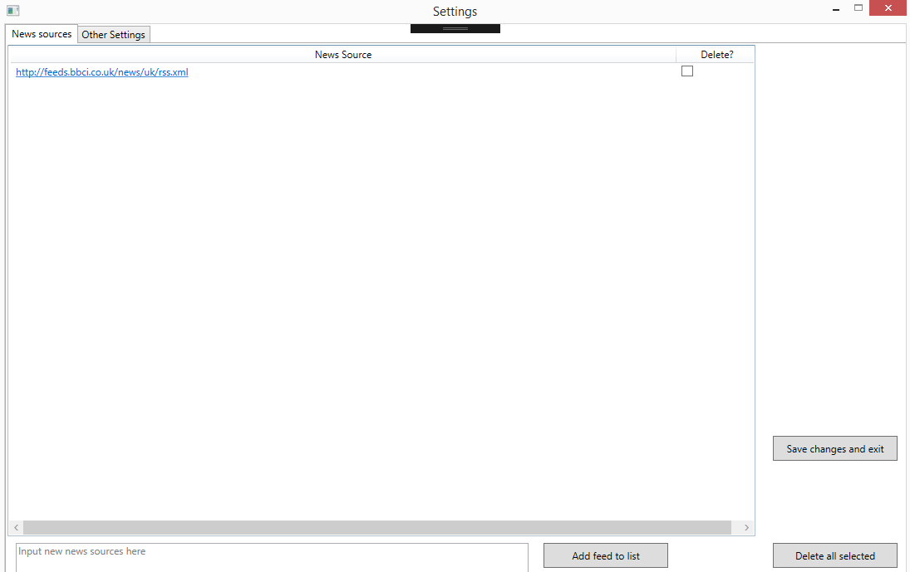

If you no longer want to receive news from this source, you can click on the checkbox and then press the button “Delete all selected”, which will remove it from the list. The second tab holds other related ticker settings:

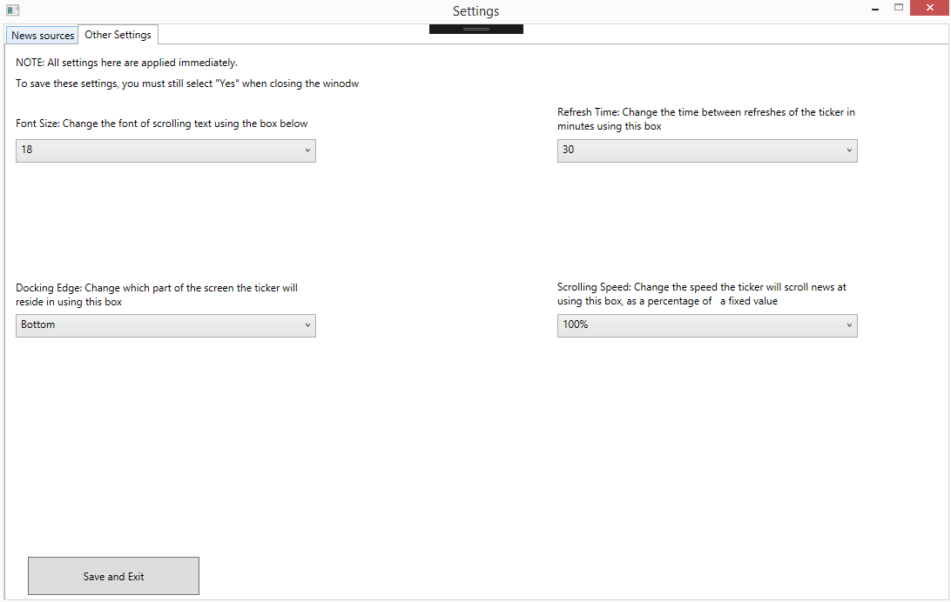

Usage

As mentioned at the top, to save the settings between application runs you must select the “Yes” option when the button “Save and Exit” is pressed, which saves these settings and changes to the feed list. Selecting no will cause the settings on this second tab to apply, but they will not be saved if the application is closed and reopened.

When a news source or multiple sources have been added to the ticker, news should scroll along the main window as seen below:

If you are interested in an item of news and desire to view it later, then right click on the item and press the “Watch Later” option, which appears as a context menu. This will bring up the following message:

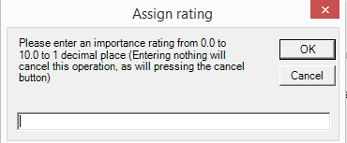

Typing in a non-numeric value or a value that is out of range will display an error message. Typing in any value with more than 1 decimal place will cause that value to be rounded in the standard method (E.g 9.89 rounds to 9.9). After adding in a rating and pressing ok, the dialog disappears and the item is added to a database in the background. To view the contents of this database at any time, press the “Watch Later” button on the main window, again bringing up this dialog:



Pressing yes will then open the following window. If you have not added any items to the database then the list will be blank.

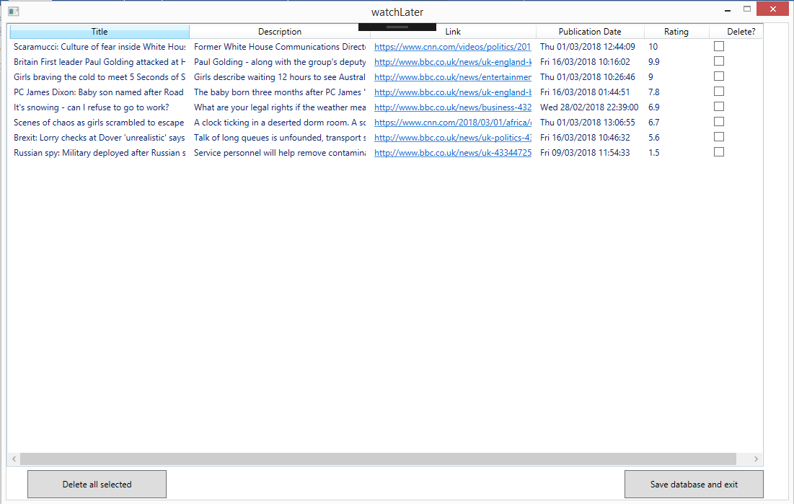Usage

As can be seen, news items are sorted in order of their rating automatically, and using checkboxes feeds can be deleted as needed. When news is scrolling or in the watch later database, the full article can be opened. This can be done in the main ticker by clicking on the title of a piece of scrolling news, or the highlighted blue link in the watch later window.

Potential Problems

1-The list of news feeds is suddenly blank

Reason: The feeds.txt file in the installation folder has been moved or deleted. A new blank file will be created, but do not move or delete this file if you want your set of feeds to be persistent.

2-The watch later database has suddenly disappeared

Reason: As with number 1, the watchLater.csv file has either been moved or deleted from the install folder. A new blank file is deleted, but do not move or delete this file if you want the database to be persistent

3-Changes to animation speed/font/docking edge/refresh interval did not save between application runs

Reason: If yes is not pressed when exiting the settings windows these settings will apply, but not save between application runs. To keep these settings, press the yes button at this dialog.